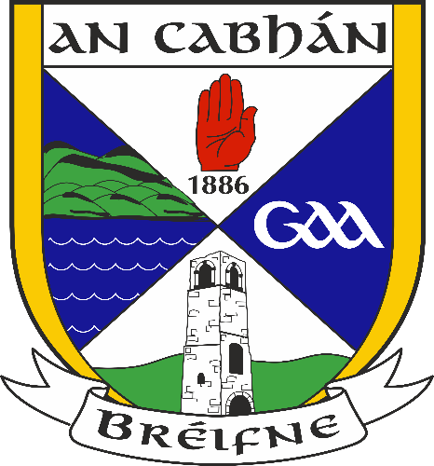

Cavan GAA
(Coiste Bhreifne Úi Raghallaigh)

Recruitment For the Position
of
ACCOUNTS ASSISTANT
KINGSPAN BREFFNI

Closing Date for REceipt of APPLICATIONS:
Tuesday 4th april 2023

The Competition:
Applications are invited for the position of Accounts Assistant with Cavan GAA. The position is full time, permanent and subject to satisfactory completion of a probationary period.

The Role:
The Accounts Assistant is primarily a book keeping/administrative role. He/she will be responsible for managing accounts, payroll, banking, payments, and general office administrative duties within Kingspan Breffni. The position is office based.

Duties and Responsibilities:
The person employed shall have overall responsibility for the following tasks:
Accounts Payable
- Ensure all supplier invoices are processed appropriately ensuring the correct control systems are utilised.
- Ensure creditor reconciliations are completed on a timely basis and that reconciling items are resolved timeously.
- Communicate with suppliers regarding invoice status, approvals, discrepancies and expected payment dates.
- Provide feedback to supervisors on anomalies and identify opportunities for improvements.
Accounts Receivable
- Prepare and post customer invoices and receipts
- Allocate payments made via cash, card and electronic methods.
- Post journals
- Post credit card receipts and debtor reconciliation
- Prepare and send out monthly statements
Banking/Accounts
- Prepare bank lodgements
- Prepare bank reconciliations
- Accounts preparation
Other Duties
- Payroll
- General administrative duties
- Liaison with clubs and governing bodies
- Such other duties as maybe assigned by your line manager from time to time

Qualifications for the Posts

CHARACTER
Candidates must be of good character.

Health
A candidate shall be in a state of health such as would indicate a reasonable prospect of ability to render regular and efficient service. The successful candidate will be required to undertake a medical examination prior to appointment.

EDUCATION, experience, training & Skills

Candidates shall:

(a) have a good general standard of education

b) have a minimum of two year’s experience working in an office based environment

A relevant third level qualification is desirable but not essential criteria to apply for the post.
The ideal candidate will be required to demonstrate through his/her CV and at interview:

- Experience in book keeping and office management
- Proficiency in Microsoft word, excel and general IT
- Ability to work to tight deadlines
- Excellent numerical ability and attention to detail
- Good administration, interpersonal & communication skills
- General willingness to learn and develop
- Positive attitude, motivated and diligent
- Able to work on own initiative
- Have an interest in sport and Cavan G.A.A.
- Good organizational skills, ability to work as part of a team & take direction

details and Particulars

Probation
Employment will be subject to a six month probationary period. During the probationary period the Employees suitability for, and performance of his/her role will be assessed. The employer may at its discretion extend the employees probationary period by an additional period of up to five months. Where service during the probationary period, or such extended period as is granted by the employer, is deemed unsatisfactory the employer shall terminate the employment.

Remuneration:
€26390

Working Hours
The working week shall be 35 hours, Monday to Friday. Given the nature of the employment, the employee may be required to work additional weekly hours on occasion. Where the employee is required to work hours outside the normal working week time in lieu will apply.

Annual Leave:
The Employee will be entitled to 20 days annual leave plus bank holidays

Residence:
The Employee will be expected to reside at an address within a reasonable distance of his/her place of work.

GARDA VETTING
Prior to appointment the successful candidate will be required to comply with Garda vetting requirements.

PENSION Contribution
The Employer does not operate an occupational pension scheme. The Employer will facilitate access to a Personal Retirement Savings Account.

sHORTLISTING
Candidates may be shortlisted for interview using pre-set criteria. Shortlisting will be on the basis of information set out by the candidate on the CV. It is important therefore that the candidate provides a detailed account of his/her qualifications, experience and skills relevant to the role, when completing their CV.

interview
At interview candidates will be assessed under the following headings:
- Knowledge & experience relevant to the post
- Planning & organisational skills & teamwork experience
- Communication/interpersonal/IT skills
- Personal Effectiveness

closing date
CV’s should be submitted via email to; recruitment.cavan@gaa.ie. The closing date for receipt of applications is Tuesday 4th April 2023.

