Cavan GAA
Kellogg’s GAA Cúl Camp Coach
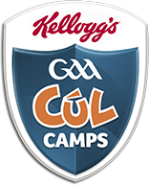
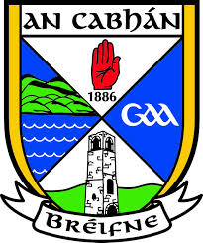
Application Form 2018

Instructions:

- Only information submitted on the application form will be considered. CVs or any other information will not be accepted and will not be used for shortlisting purposes.
- The completed application form must be returned to Cavan GAA to arrive not later than 5.00pm on Friday, 4th May 2018.
- It must be returned to:
Cúl Camps, Cavan GAA Coaching and Games, Kingspan Breffni, Cavan.
OR Email completed forms to coachingadmin.cavan@gaa.ie
- Applications must hold a minimum of a GAA Foundation Level or equivalent and be a minimum of 18 years old, prior to being of camps to be considered.

All sections of the form must be completed.
Personal Details
First Name |  | Surname
Address
Date of Birth |  | Club
PPS Number |  | Contact Number
Do you drive? | Yes No | Email Address

Education
Currently studying at what level please tick |  | Leaving Cert Third level
If attending third level- What College & What course
If not at college please state;
Your occupation:
If unemployed please state whether on UA, UB, Disability or other – specify
If on UA, UB, Disability or Other, when you are working on the camps will you be coming off one of these Social Welfare Schemes? |  | Yes No
Coaching Information
Do you hold the minimum of a Foundation Level or equivalent? | Yes No
Please outline your Coaching Experience
Coaching Qualifications: Please include level and dates of courses
Have you completed the Online GAA Garda vetting procedure & received clearance?
Yes No
If yes please provide a copy. If no please apply ASAP through your clubs Children’s Officer.

Saturday work: Please be aware you may be asked to work on Saturday’s during your employment.
Availability to work: Please tick ALL boxes if you are available to coach on all camps or selected boxes if you are available for certain full week camps. Coaches must attend the full week of each camp. Changes by you to the committed weeks of work will not be accepted.
Camps Week & Dates | Please tick box
Week 1: June 25th – June 29th
Week 2: July 2nd – July 6th
Week 3: July 9th – July 13th
Week 4: July 16th – July 20th
Week 5: July 23rd – July 27th
Week 6: July 30th – Aug 3rd
Week 7: Aug 7th – Aug 10th

Anybody wishing to receive summer camp work will have to undertake a practical assessment & attend a two-day training programme.
Signature of Applicant |  | Date

